**Davao Oriental State University**

*A University of Excellence, Innovation and Inclusion*



Project concept

Programming Language 1 (ITC-101)

*Final Project*

**“Calendar Maestro: Your Customizable Monthly Companion”**

Reynand L. Argallon

BSIT-1D

1st year

Rich Anjo Morilla Capiloyan

*Instructor*

November, 28, 2024

**Description**

This pledging piece of program in Java is a calendar that allows you to look at your schedule with some resiliency in it. Consider it to be a friendly monthly companion that gives you a simple and structured perspective of what lies ahead. The program begins with making imports of the classes from the java.util package as these are important in placing the dates and times, taking user input, and calendar imposition. Classes such as Calendar and GregorianCalendar give the basic mechanics of dealing with particular days and months while Scanner makes the interface interactive and Locale ensures receival of the correct version of the calendar in terms of the user’s language and area.

Speaking about the central part of the program, it allows the user to enter a year and then offers them to select a month or the whole year for viewing. This simple interface allows for a manipulative perspective in terms of calendar viewing. The program then calls the GregorianCalendar class to establish a calendar object depicting the year and month selected by the user. At the core of the function is the displayCalendar method which accepts a calendar object and creates a nicely formatted calendar. The method first shows the month and year and then the days of the week which are Sun, Mon, Tue and so on. It then compute

**Structure**

1. **Input Gathering:**

- At the beginning of the program, a prompt is issued to the user to input the year they wish to work with.

- Another prompt requests that the user make a choice between displaying a specific month ('M') or the entire year ('Y').

- Where the user opts to have a specific month displayed, a prompt for the month number (1-12) is issued.

2. **Calendar Initialization:**

- The program uses the  GregorianCalendar  class to instantiate a calendar object of the specified year and month.

It is then adjusted by subtracting 1 because the month is zero-based in GregorianCalendar (0 for January, 1 for February, and so on).

3. **Calendar Display:**

- The program calls the displayCalendar method passing the calendar object as an argument.

- The displayCalendar method will do the following:

- Extract the month and year from the calendar object.

- Invoke the getDisplayName method to obtain the month name (in English).

- Print the month name and year.

- Print the days of the week header (Sun, Mon, Tue, etc.).

- It determines the day of the week for the first day of the month.

- It uses a  for  loop to print spaces before the first day of the month to align the calendar properly.

- It uses a  while  loop to iterate through the days of the month, checking for the end of the month.

**Code**

import java.util.Calendar;

import java.util.GregorianCalendar;

import java.util.Locale;

import java.util.Scanner;

public class CalendarProgram {

public static void main(String[] args) {

Scanner scanner = new Scanner(System.in);

System.out.print("Enter year: ");

int year = scanner.nextInt();

System.out.print("Enter 'M' for a specific month, 'Y' for the whole year: ");

String choice = scanner.next();

if (choice.equalsIgnoreCase("M")) {

System.out.print("Enter month (1-12): ");

int month = scanner.nextInt();

Calendar calendar = new GregorianCalendar(year, month - 1, 1);

displayCalendar(calendar);

} else if (choice.equalsIgnoreCase("Y")) {

for (int month = Calendar.JANUARY; month <= Calendar.DECEMBER; month++) {

Calendar calendar = new GregorianCalendar(year, month, 1);

displayCalendar(calendar);

}

} else {

System.out.println("Invalid choice. Please enter 'M' or 'Y'.");

}

}

public static void displayCalendar(Calendar calendar) {

int month = calendar.get(Calendar.MONTH);

int year = calendar.get(Calendar.YEAR);

String monthName = calendar.getDisplayName(Calendar.MONTH, Calendar.LONG, Locale.ENGLISH);

System.out.println("\n" + monthName + " " + year);

System.out.println("Sun Mon Tue Wed Thu Fri Sat");

int firstDayOfWeek = calendar.get(Calendar.DAY_OF_WEEK) - 1;

for (int i = 0; i < firstDayOfWeek; i++) {

System.out.print(" ");

}

int day = 1;

while (calendar.get(Calendar.MONTH) == month) {

System.out.printf("%3d ", day);

calendar.add(Calendar.DATE, 1);

if (calendar.get(Calendar.DAY_OF_WEEK) == Calendar.SUNDAY) {

System.out.println();

}

day++;

}

System.out.println();

}

}

**Output**

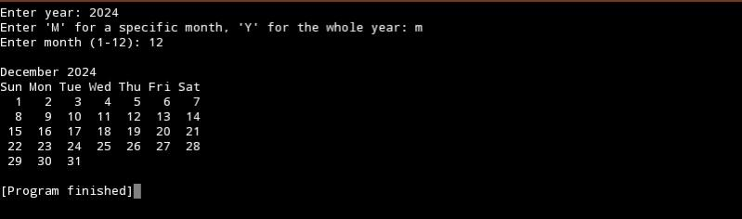Specific month only

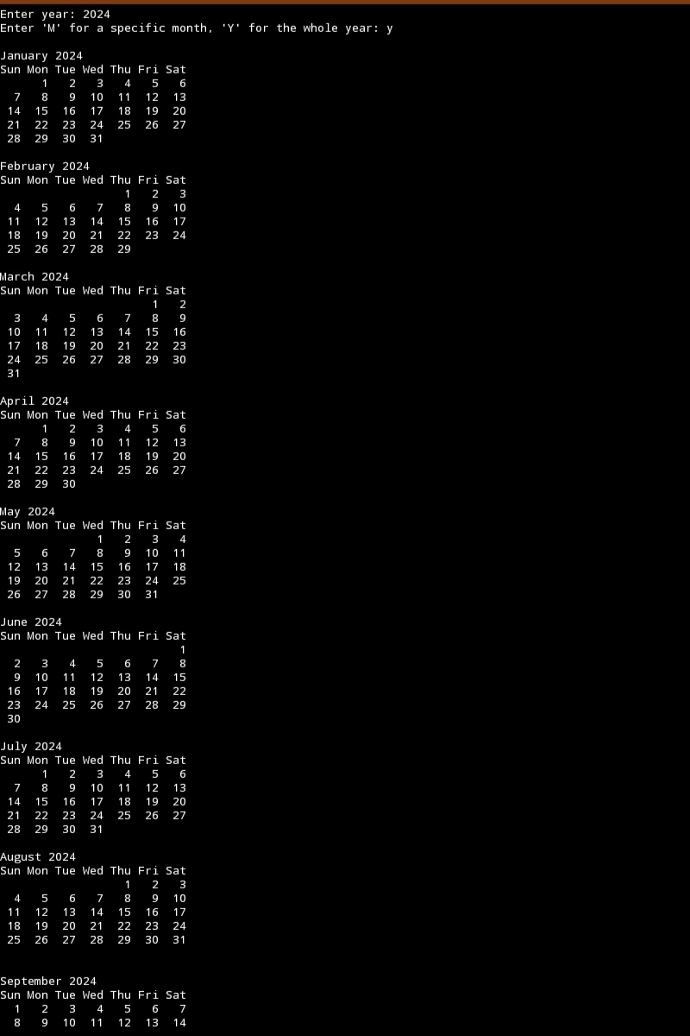whole year